**Computer Graphics**

**BSCS-7A/B**

|  |
| --- |
| **Lab 3: Keyboard and mouse interaction** |

Objective(s): Upon completion of this lab session, learners will be able to:

|  |
| --- |
| 1. Implement key board and mouse interaction |

Exercise 1

1. Write a program to draw sierpinski gasket.(This part is already done in previous lab use previous code and do changes)

Instructions: background color should be white and drawing color should be black

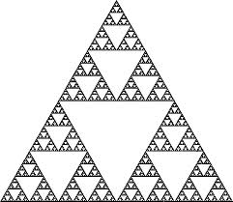

1. **Keyboard interaction**

Make following changes in task 1

1. Press ‘r’ to change drawing color to red
2. Press ‘y’ to change drawing color to yellow
3. Press ‘e’ to exit
4. **Mouse interaction**

Make following changes in task 1

1. Click left button to change drawing color to blue
2. Click right button to exit

Exercise 2

Draw dots on mouse click. Use left click for drawing and right for exit.

**Note** (because the y-value of the mouse position is the number of pixels from the top of the screen window, draw dot not at(x, y) but(x, Screen Height-y)

.

Exercise 3

Write a program to draw line by click two points

Exercise 4

Draw Sierpinski gasket by choosing three points on click.